Concern for rights of the common man, 1647 - # 61
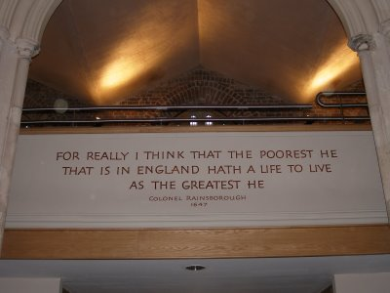The church features this "headline statement" made during the Debates by the puritan Colonel Rainsborough, expressing his concern and his hope for the Common Man in England: - naturally, it reaches out to everyone.
This photo series on St. Mary's Putney, the Putney Debates and the Levellers will finish tomorrow.
Posted by Chuckeroon at 07:49 3 comments Links to this post
Labels: 1647, Colonel Rainsborough, English Civil War, Putney Debates, St.Mary's Putney

28 March 2007

Can somebody please tell me what's happening? - # 60
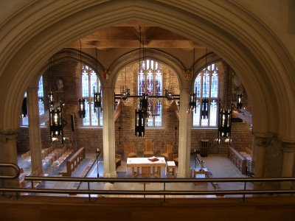
History goes through phases. First: chaos - the "What on earth is going on?" phase. Second: - the Party Line when winners tell us what was really going on. Third: the Revisionist phase -when counter revolutionaries deny it all and tear down myths, only to erect their own, usually wrong myths. Finally: chaos again - the "I still haven't a clue what happened" phase, when we just give all the records to the kids, let them draw their own conclusions, and we end up with 1,000 crazy views based on personal foibles.
The Putney Debates were all written down, and kept. We have it word for word; the whole discussion. It's a unique insight - fully recorded 17th Century political debate with important implications that still impact on modern Britain.
Here is the modern, restored interior of the church. Imagine Cromwell slugging it out verbally with his radical commanders, and a couple of diligent scribes scribbling furiously, catching the whole thing for posterity. Suddenly Cromwell finds the debate going in directions that he never expected. His men are more radical than he is. "Can somebody please tell me what's happening?"
Posted by Chuckeroon at 13:20 4 comments Links to this post
Labels: Cromwell, English Civil War, Putney Debates, St.Mary's Putney

27 March 2007

We struggle to climb higher, but slide so easily down - # 59
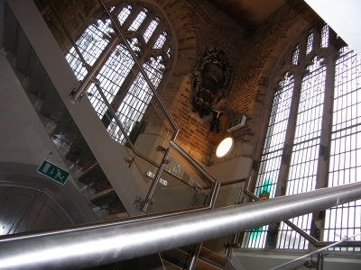
It's a hard climb towards high ideals. St. Mary's church, Putney, site of the Putney Debates in 1647, was destroyed by fire in 1973, and has been superbly rebuilt in modern style using the finest materials. http://www.theteacher99.btinternet.co.uk/ecivil/putney.htm Read here, briefly, how the radical "Levellers" - radical puritan, protestant, political thinkers from Cromwell's finest, elite cavalry regiments - highjacked the debate and turned it into a discussion on modern democracy as we know it today.

